A

Project Report on

**Computer Lab Set Up in CISCO Packet Tracer**

Submitted in partial fulfillment of completion of the course

Advanced Diploma in IT, Networking and Cloud

Submitted by:

**Manjima Bhattacharyya**

**Anoushka Das**

Under Guidance of:

**Arpita Roy (Edunet)**

|  |  |  |
| --- | --- | --- |
|  |  |  |

Year 2022-2024

Abstract

Acknowledgement

Team Composition and Workload Division

Table of Contents

1. Introduction to Problem
2. Proposed Solution
3. Requirements

3.1 Technology Stack

3.2 Hardware

3.3 Software

3.4 Deployment Environment

4. User Requirements

5. Design Documentation

6. Implementation Details

7. Testing

8. Deployment

9. Conclusion

Appendix A Screenshot of Project

References

**Abstract**

The basic idea is to allow self-determining and confidential communication to exchange of data between real-world devices and applications of the Internet of things. Computer network area requires professionals with solid networking theory and practical hands-on experience.

Together with the fast-technological advancement in the field of computer networks and Information Technology industry, the need for a large number of skilled network experts also increased.

Cisco Packet Tracer is an effective education simulation software that supports computer networking students to experiment and practice network tasks. Cisco Networking Academy Program (CNAP) introduced Packet Tracer as a tool for teaching and learning of computer network courses by providing “simulation, visualization, authoring, collaboration capabilities and assessment”

**Acknowledgement**

Team ‘Trailblazers’ (comprising of 2 members, namely Manjima Bhattacharyya & Anoushka Das) are thankful to our teacher,Ms. Arpita Roy for her guidance and supervision which has provided a lot of resources needed in completing our project.

We are also thankful to the efforts put in by our team members and contributions to the preparation of this project.

**Team Composition and Workload Division**

Our team comprises of 2 members.

1. Manjima Bhattacharyya : Leader

Design and configuration of the network infrastructure in CISCO Packet Tracer.

2. Anoushka Das: Member

Testing, troubleshooting, Documentation.

**Introduction to Problem**

Computer network area requires professionals with solid networking theory and practical hands-on experience. Together with the fast-technological advancement in the field of computer networks and Information Technology industry, the need for a large number of skilled network experts also increased.

Cisco Packet Tracer is an effective education simulation software that supports computer networking students to experiment and practice network tasks.

**Proposed Solution**

The use of virtual laboratories is very important. In this study, we also implemented Cisco Packet Tracer, which enables us to work on test scenarios without using any physical components virtually to design an advanced computer network. The Cisco Packet Tracer is used not only to simulate computer networks but also to learn computer networks.

**Requirements**

|  |  |
| --- | --- |
| Technology Stack: | Networking |
| Hardware: | Processor: Intel(R) Core (TM) i5-9500 CPU @ 3.00GHz 3.00 GHz |
|  | System type 64-bit operating system, x64-based processor |
| Software: | CISCO Packet Tracer |
| Deployment Environment: | It is deployed in CISCO Packet Tracer |

**User Requirement:** Students

**Design Documentation**

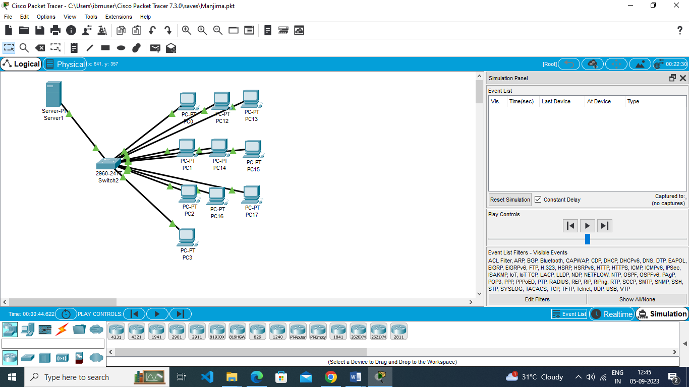

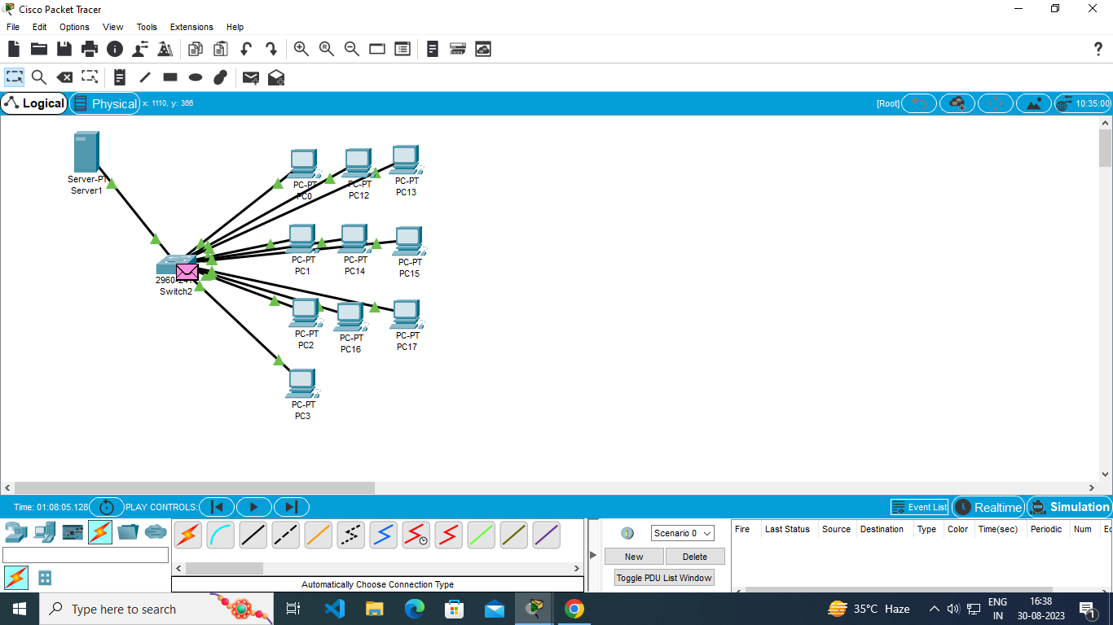

**IMPLEMENTATION DETAILS**

**Step 1: Open Packet Tracer**

Open Cisco Packet Tracer on your computer.

**Step 2: Create a New Network**

Click on "File" in the top-left corner.

Select "New" to create a new network

**Step 3: Select Devices**

From the left panel, select "End Devices."

Drag and drop "PC" devices onto the workspace. You can add as many PCs as you want for your computer lab. Here I am taking 20PCs for my project.

**Step 4: Connect Devices**

From the left panel, select "Connections."

Choose the appropriate cable type (usually Ethernet) and connect the PCs by clicking on the PC's network interface and then clicking on another PC's interface to create a connection.

**Step 5: Configure PCs**

Click on a PC to select it.

Click on the "Desktop" tab in the pop-up window.

A command prompt window will open. You can perform basic configurations like setting IP addresses, subnet masks, and default gateways using commands like ipconfig.

Here the IP addresses is 169.254.0.8(it is for one pc for other pc it is diffirent)

Subnet Mask: 255.255.0.0

**Step 6: Test Connectivity**

Open the command prompt on each PC and use commands like ping to test connectivity between PCs. For example, ping <destination IP>.

**Step 7: Save the Work**

To save your Packet Tracer project to retain your lab setup for future use.

**TESTING**

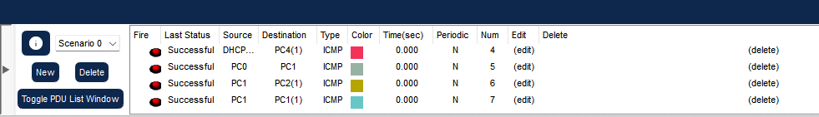

**DEPLOYMENT**



**FUTURE SCOPE**

Packet tracer provides network simulation and visualization. It can be used to enhance and improve the practical knowledge of computer networking principles among students. Moreover, students can design mini-projects with solutions with more innovation and creativity. As with other tools, students are able to understand the use of different networking protocols but they are not able to understand the application of these protocols in the real networks, thus packet tracer can be used to design and configure a network, and understand the application of various protocols. As students can’t access different networking devices, because of the cost, also devices may be damaged and further, movement of packets from source to destination can’t be seen in a real-time, thus by using packet tracer, students can access the virtual network devices any time and no damage can be caused to devices, moreover the movement in packets can be shown by simulations.

Packet Tracer can further be used, to understand the difference between different networking devices like hubs, switches, routers etc and their appropriate use while connecting various Computers to design a network. How to assign logical address to various networking devices like computers, routers etc appropriately. While moving from source to destination, which route is selected by a packet depending on various routing protocols? Type of cable to be used while connecting different networking devices. Checking connectivity between different networking devices by running various networking tests.

Basic networking concepts like DNS, DHCP, NAT, routing etc can be easily explained by using packet tracer and students can build, configure and troubleshoot networks using packet tracer. It also makes teaching easier, students can create their own scenario based labs and provides real simulated and visualization environment .

**CONCLUSION**

Cisco Packet Tracer is a tool built by Cisco and it provides network simulation to practice simple and complex networks. The main purpose of the Cisco Packet Tracer is to help students learn the principles of networking and demonstrate the networking concepts. A DHCP Server is a network server that automatically assigns IP addresses, default gateways, and other network parameters to client devices.

This work contributes to our understanding of computer lab’s and provides a foundation for future research and action in this area.

**APPENDIX A: SCREENSHOT OF THE PROJECT**



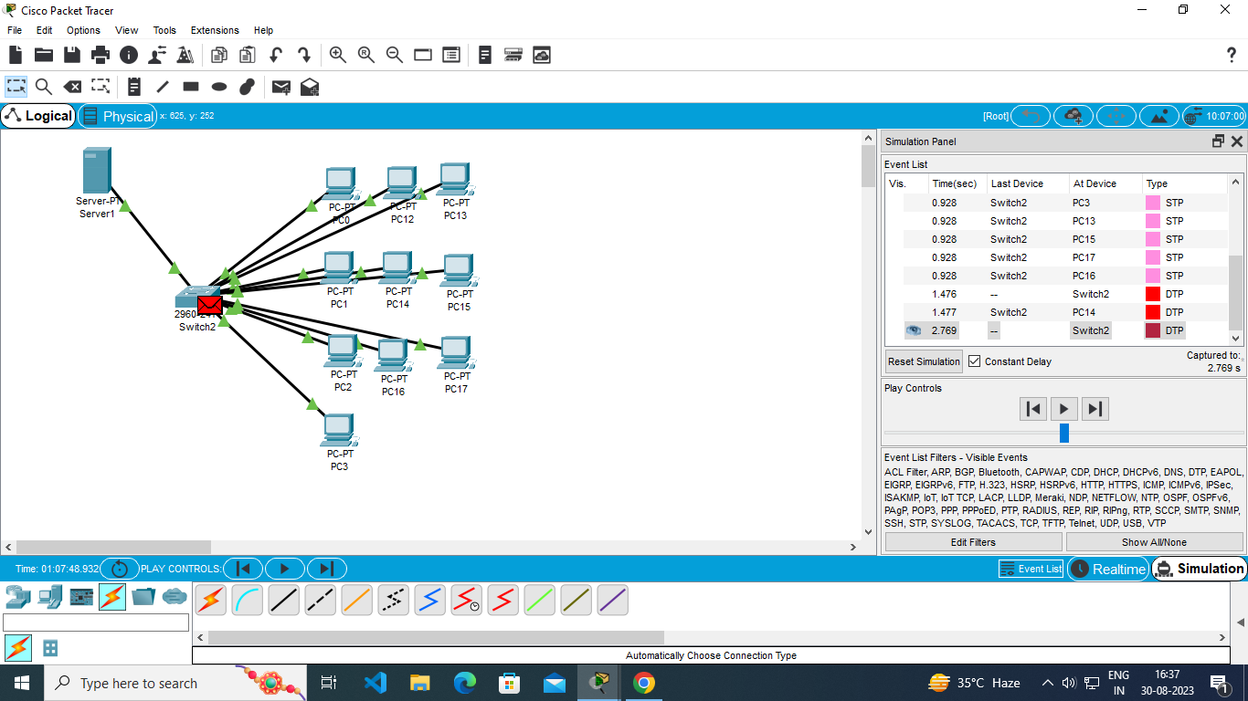

**References**

* <https://www.studocu.com/row/document/air-university/computer-networks/computer-networks-lab-1-introduction-to-packet-tracer/25440272>
* <https://www.geeksforgeeks.org/how-to-make-computer-lab-in-packet-tracer/>
* <https://www.youtube.com/watch?v=UFy0icmOI0k>
* <https://www.netacad.com/courses/packet-tracer>